A SYNOPSIS
ON

EXPENSE MANAGEMENT
submitted in partial fulfilment of the requirements for the award of degree of

BACHELOR OF ENGINEERING
In
COMPUTER SCIENCE AND ENGINEERING

Submitted by: Supervised By:
<Saket Bansal > <Dr. Gurpreet Singh>
<2210992217> < Assistant Professor>
< Department of CSE>



DEPARTMENT OF COMPUTER SCIENCE AND ENGINEERING

CHITKARA UNIVERSITY INSTITUTE OF ENGINEERING AND TECHNOLOGY
CHITKARA UNIVERSITY, PUNJAB, INDIA

TABLE OF CONTENTS
- Introduction 1-2
- Feasibility Study 3
- Objectives 4
- Features 5-6
- Methodology 7
- Facilities / Planning of Work 8
- Bibliography 9

INTRODUCTION

  - Introduction: -
In today’s fast-moving world, managing money properly has become very important for individuals as well as businesses. Many people spend money daily on food, travel, shopping, bills, and other activities, but they do not keep proper records of their expenses. Because of this, they often face financial problems, overspending, and difficulty in saving money. An Expense Management System is designed to solve this problem by helping users track, manage, and control their income and expenses in an organized and efficient way.
An Expense Management System is a software application that records daily financial transactions. It allows users to add their income and expenses, categorize them, and view summaries in the form of reports and charts. Instead of writing expenses in notebooks or calculating manually, this system stores all financial data digitally in a database. This makes the process faster, more accurate, and more secure.
The main purpose of this project is to provide a simple and user-friendly platform where users can monitor their financial activities. The system automatically calculates the total income, total expenses, and remaining balance. It also helps users analyze their spending habits through monthly or yearly reports. By seeing graphical representations like pie charts or bar graphs, users can easily understand where their money is being spent.
Manual expense tracking systems have many disadvantages such as calculation errors, data loss, difficulty in searching old records, and lack of proper analysis. The proposed Expense Management System overcomes these problems by providing features like secure login, categorized expense entries, search and filter options, and automatic report generation.
This project can be useful for: -

- Individuals who want to manage personal budgets.

- Students who want to track pocket money.

- Small businesses to monitor daily transactions.

- Families who want better financial planning.

  - Technologies Used: -
An Expense Management Project can be developed using different technologies. These technologies are divided into Frontend, Backend, Database, and Additional Tools.
    - Frontend Technologies: -
      - HTML (Hyper Text Markup Language): -

It creates the structure of the website.

It is used to make forms, buttons, tables, and input fields.

In this project, it is used to create income and expense forms.
      - CSS (Cascading Style Sheets): -

It is used to design and style the website.

It controls colors, layout, fonts, and spacing.

It makes the dashboard look attractive and professional.

      - React: -

It is a modern JavaScript library.

It helps in building fast and responsive user interfaces.

It uses components to organize code.

It is suitable for large and modern applications.

    - Backend Technologies: -
      - Node.js: -

It allows JavaScript to run on the server.

It handles login, signup, and saving data.

It creates APIs to send and receive data from the frontend.

      - MySQL: -

It is a structured database system.

It stores data in tables (rows and columns).

It is commonly used with PHP projects.

FEASIBILITY STUDY

A feasibility study checks whether the project is practical and possible to develop. It helps to understand if the project can be completed successfully with available resources.
There are mainly five types of feasibility studies: -

      - Technical Feasibility: - This checks whether the project can be developed using available technology.

- Required technologies (HTML, CSS, JavaScript, PHP, Node.js, MySQL, etc.) are easily available.
- Development tools like VS Code and browsers are free to use.
- Database systems are reliable and secure.

      - Economic Feasibility: - This checks whether the project is cost-effective.

- Most technologies used are free or open-source.
- No expensive hardware is required.
- Development cost is low.
- It saves money by reducing manual work and errors.

      - Operational Feasibility: - This checks whether the system will work properly in real life.
- The system is easy to use.
- Users can add, edit, and delete expenses easily.
- It reduces manual calculation work.
- Training required is minimal.
      - Legal Feasibility: - This checks whether the project follows legal rules and regulations.

- No illegal software is used.
- User data can be stored securely.
- Privacy and data protection rules can be followed.
- Licensed software can be used if required.
      - Schedule (Time) Feasibility: - This checks whether the project can be completed within the given time.

- The project is small to medium size.
- It can be completed within academic project duration.
- Development time depends on features included.
- Basic version can be developed quickly.

OBJECTIVES
The main objective of an Expense Management is to help users manage their money properly and keep financial records in an organized way.
      - To Record Income and Expenses: -
- The system allows users to add their daily income and expenses.
- It reduces the need for manual writing in notebooks.

      - To Calculate Total Income and Total Expenses: -
- The system automatically calculates total income and total expenses.
- It shows the remaining balance clearly.
- It reduces calculation mistakes.

      - To Categorize Expenses: -
- Users can divide expenses into categories like food, travel, bills, shopping, etc.
- It makes financial tracking more organized.

      - To Provide Data Security: -
- The system includes login and password protection.
- User data is stored safely in a database.
- It prevents data loss and unauthorized access.

      - To Reduce Manual Work: -
- No need for manual calculations.
- Everything is stored digitally.
- Searching old records becomes easy.

FEATURES

The Expense Management System has many useful features that help users manage their income and expenses effectively.

      - User Registration and Login: -
- Users can create a new account.
- Secure login with username and password.
- Only authorized users can access their records.
      - Dashboard Overview: -
- Shows total income.
- Displays remaining balance.
- Provides quick summary of financial status.
      - Add Income Feature: -
- Users can add income details.
- Includes date, amount, and source (salary, business, etc.).
- Income records are saved in the database.
- User can edit or delete income entries.
      - Expense Categories: -
- Expenses can be divided into categories like Food, Travel, Bills, Shopping and Entertainment.
- Users can also create custom categories.
- Helps analyze spending habits.
      - Automatic Calculation: -
- System automatically calculates Total income, Total expenses and Remaining balance.
- Reduces manual calculation errors.
- Provides accurate financial summary.
      - Reports Generation: -
- Generates monthly and yearly reports.
- Shows category-wise spending.
- Makes budgeting easier.

      - Search and Filter Option: -
- Users can search records by date or category.
- Filter expenses within a specific time period.
- Makes finding old records easy and fast.

      - Edit and Delete Records: -
- Users can modify incorrect entries.
- Delete unwanted records.
- Keeps data updated and accurate.
      - Data Storage and Security: -
- All data is stored in a database.
- Secure storage system.
- Can include password encryption.
- Prevents data loss.

Methodology
The Methodology is a systematic process or step-by-step procedure used to develop the Expense Management System. It explains the project planning, designing, developed, testing, and implemented of project in an organized way.
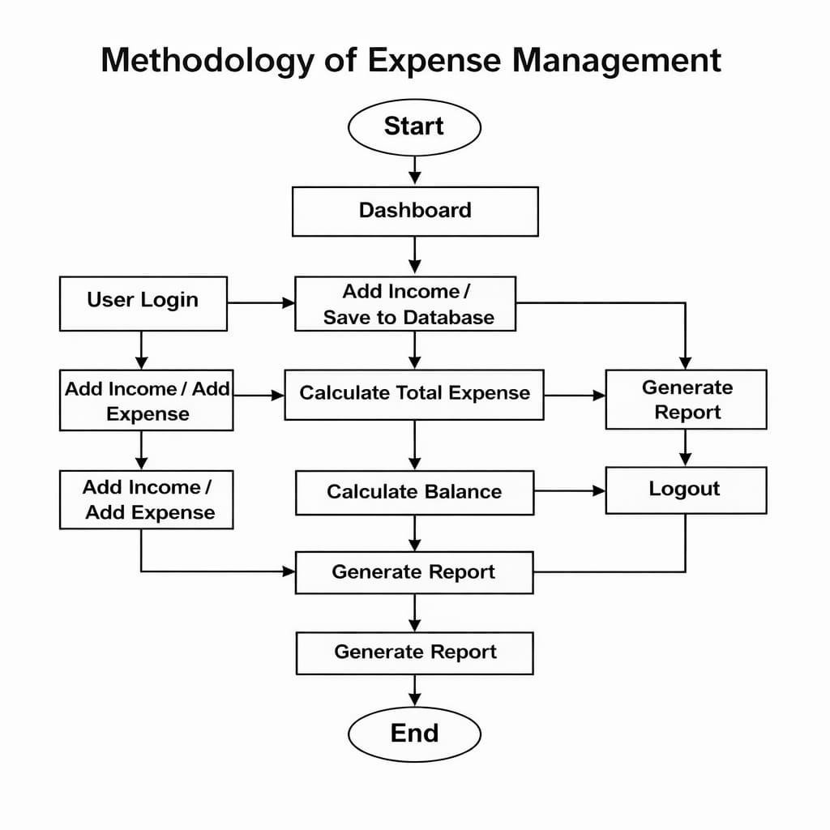

Figure 1

  - Planning of Work: -

Planning of work means deciding how the project will be completed step by step within a specific time. It helps to organize tasks properly and complete the project smoothly.

In the Expense Management System, planning of work includes the following steps:-

Understanding the project objectives and purpose.

Collecting user requirements like income entry, expense tracking, and report generation.

Deciding the features and modules of the system.

Selecting suitable technologies (frontend, backend, database).

Creating a timeline to complete each phase of the project.

Dividing the work into small tasks (design, coding, testing).

Testing the system to remove errors.

Deploying the final project and preparing documentation.

  - Facilities Required for Proposed Work
To successfully develop and deploy the website, the following resources are required:
- Hardware: Laptop/Desktop with a good processor and RAM (16GB).

Software: Windows, Visual Studio code.
- Frontend: React.js / Vue.js, HTML, CSS, JavaScript.
- Backend: Python / Django.
- Database: MongoDB / MySQL.
- Development Tools: VS Code, GitHub.

Website Blocker
6 Bibliography

- YouTube: - https://youtu.be/2600EyK1o_A?si=GDoEb4J1LKhu_67h
- Documentation:-https://developer.mozilla.org/
- MySQL Official Website (Database Reference):-https://www.mysql.com/

- Software Engineering Concepts (SDLC, Feasibility Study, etc.):- https://www.geeksforgeeks.org/software-engineering/

2206338,2305720 Page no. 9

